  - St. Charles Borromeo Catholic Church
THE VIGIL

Sunday, November 23, 2025 (Year C)

Our Lord Jesus Christ, King of the Universe

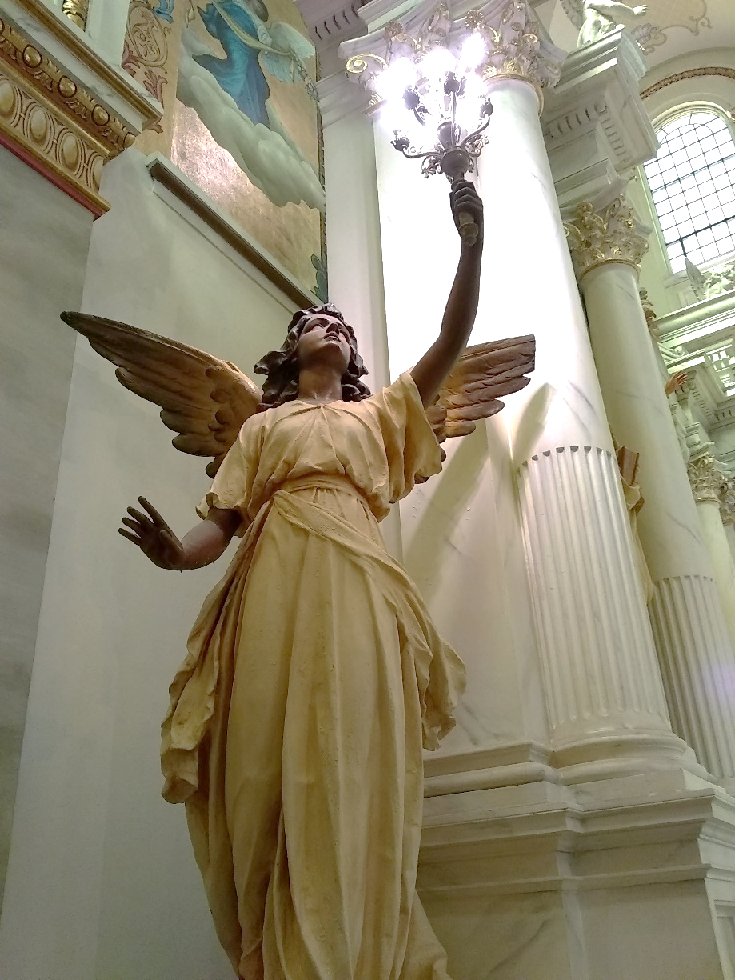

“With a Prayer…”

Sunday Food for Your Soul

Christ the King

The leaders and the soldiers made fun of Jesus, and there was an inscription over his head: “THIS IS THE KING OF THE JEWS”. Pilate had this written not only to mock Jesus, but to mock the Jews: “Look here is your king!” Why did Jesus meet such animosity? Well, just look at our world and see what kind of people become rulers. They often are self-centered individuals who pander to what people desire: lower taxes, my country must be the strongest and richest even if it means mistreating citizens of weaker nations. To many, justice, love, and peace are seen as foolish idealism. Jesus was mocked by many because he was not good for the economy, nor was he the strong military leader that they desired. The children of this world lust after immediate pleasure and political dominance. Jesus calls for followers who are willing to sacrifice and suffer for the sake of obeying God’s commandment to love. Love does conquer in the end. Jesus says to the good thief, “This day you will be with me in paradise.” Jesus Christ is a different kind of King.

As we reflect on the death and resurrection of Christ, we prepare for a year of reorganization that will test our spirits. I know I will have to pray hard to be able to truthfully say: “Thy will be done.” I will find it hard to go beyond my personal thoughts and desires and seek whatever is the best outcome for all the parish family members. We need to pass on to the next generation the strongest and healthiest parishes that we can put together. We need to look 25 years down the road to see the needs of Detroit in 2050 (when some of us will be gone). We are in the parish we are in because we the love the people and the place, we are challenged to discern what the Lord desires for our future. Brothers and sisters in the Lord: pray hard and think rationally.

Fr. David Preuss

Thoughts for Today’s Readings

Sunday Community Dinners… As one of our most important ministries to our members and neighbors, we have been blessed. We are in need of more. If you and your group would like to sponsor a meal, please contact Georgia Kingsley via the rectory. Today Sunday, November 23, 2025: Pastor Ava; November 30, 2025: NO MEAL (Holiday); December 7, 2025: Joann and George Eder; December 14, 2025: The Corner Table; December 21, 2025: Angie Kadowaki & Family; December 28, 2025: NO MEAL (Holiday); January 4, 2026: SPONSOR NEEDED; January 11, 2026: Kim & Steve Llorens; January 18, 2026: Parish Council; January 25, 2026: St. Bonaventure Secular Franciscans

Nativity Pantry News: We are so grateful for your continued support of the pantry. This week, we need Cereal, Noodles, and Peanut Butter again. And again, if you have anything extra in the cupboards, it would be greatly appreciated. In two weeks we have seen 200 families. Once again, we thank you for all that you do to help us.

Deacon Joseph, the entire St. Charles and the Detroit Lower Eastside Family of Parishes welcomes you and is glad you're here. We look forward to having you as part of our Pastoral Team.

St. Charles Upcoming Events

Parish Nurse News and Notes

Parish Nurse News and Notes-St Charles September is Prostate Cancer Awareness Month Did you know that 1 in 8 men will be diagnosed with prostate cancer in their lifetime? September is Prostate Cancer Awareness Month, a time to bring attention to one of the most common cancers among men—and to encourage early detection. What is Prostate Cancer? Prostate cancer is a disease where cancer cells form in the tissues of the prostate—a small gland in men that helps produce semen. While it often grows slowly, some forms can be aggressive. Who is at Risk? ● Men over 50 ● African American men ● Men with a family history of prostate cancer What Can You Do? ● Talk to your doctor about screening, especially if you’re over 50 or have risk factors. ● Maintain a healthy lifestyle—exercise regularly, eat a balanced diet, and don’t smoke. ● Be aware of symptoms like difficulty urinating, blood in urine or semen, or pain in the back or hips—but remember, many men have no symptoms at all.o Faith and Health Go Hand in Hand As stewards of the bodies God has given us, we are called to care for our health. Encourage the men in your life—husbands, fathers, brothers, and sons—to speak to their doctor about prostate health.Let us pray for healing, wisdom for doctors, and the courage to take proactive steps for our well-being. Don't forget to sign up for our upcoming Diabetes Prevention program starting next week on Sunday , September 21 , from 1:30 to 2:30 in the church hall .(in the classroom).Open to all parishes in our family . We will also be having Blood Pressure screening on Sept 21 before and after mass. Blessings, Mary Catherine Wright RN, Parish Nurse
2025 St. Charles CSA Data

As of 11/11/2025 8% our our membership have contributed to the annual CSA campaign. That means that 92% of us have not contributed. No matter how small or large a donation is, we need more members to contribute as we all know that participation and support from the members is being look at by the Archdiocese of Detroit. If you want to contribute but don’t know how, please just call the office.
Detroit Lower Eastside Family of Parishes Thanksgiving Mass Schedule

Tuesday, Nov. 25th
St. Raymond - 8:30 am
Our Lady Queen/Heaven - 10:30 am
Sacred Heart - 5:00 pm
St. Augustine/St. Monica - 6:00 pm (Followed by a Pot-Luck Supper)

Wednesday, Nov 26th
St. Augustine/St. Monica 9:00 am NO MASS*

Thursday, Nov. 27th - THANKSGIVING DAY
Sacred Heart 9:00 am

Friday, Nov 28th ALL PARISH OFFICES
ARE CLOSED - NO MASSES
St. Charles Men’s Retreat is September 19-21, 2025
“Navigating Turbulent Waters”

Info about the retreat:
The retreat begins with dinner on Friday evening and ends on Sunday morning after breakfast and Mass (about 11AM). St. Paul of the Cross Passionist Retreat Center is at 23333 Schoolcraft, which is the eastbound service drive for I-96, just east of Telegraph Rd.
A retreat is a precious opportunity to renew faith, experience the loving presence of God and to seek the wisdom necessary for peaceful daily living. This year’s theme is ”Navigating Turbulent Waters”.
Protecting God’s Children News

If you have registered for an account on Virtus.com (Protecting God’s Children), but haven’t logged into your account in the past 24 months, please know that your account may have been marked as "inactive" or "suspended". If you try to login and get a message that your account is inactive or suspended, please contact the parish office for assistance.
Each man has his own bedroom and bathroom—all linens provided. The suggested donation is $225.00, and retreatants are asked to give whatever they can afford to cover the costs. To register see or call James Taylor at 313.622.4505 or call Christine at the Retreat Center at 313-535-9563. You may also register online at Register Here. A $30.00 deposit will hold your place.

The VIGIL Parish News and More

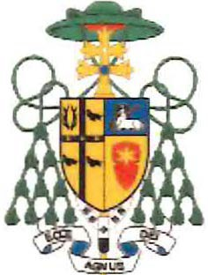

ARCHBISHOP OF DETROIT
November 15, 2025

Dear Brothers and Sisters in Christ,
Since arriving in Detroit this past March, I have had the great joy of meeting many of you at parish celebrations, diocesan gatherings, Mass, and other liturgies. In every encounter, I have seen something truly beautiful. I have witnessed your deep love for Christ, your local parish, and our Archdiocese. I also have witnessed your intense desire to see the Church of Detroit flourish for generations to come.
Along with our many blessings, I have also heard the candid expression of your concerns and your understanding of the challenges we face now and into the future. Please know that I hear you and that I see these challenges, too. Many of our churches were built during a time of tremendous growth, when more than 1.5 million Catholics called this Archdiocese home. Today, our Catholic census is closer to 900,000, with a smaller number regularly attending Mass. We have been struggling to maintain buildings, ministries, and structures that were designed for a much larger Church. The situation that unfolded in the last 50 years has left us stretched-sometimes stretched too thinly to serve as well as we want. Moreover, as we struggle to care for buildings and parish structures where there are very few people, we are also seeking to ensure the presence of the Church as we follow the Catholic population in those areas where the Church is growing.
While I believe that our commitment to Christ and his Church means that we must face these challenges, I do not believe that this moment in time need be marked primarily by anxiety or despair. Rather, I believe the situation we are facing is one that holds real and blessed opportunities. I believe with all my heart that God is inviting us to reimagine parish life, priestly ministry, and our mission. I believe God is asking us to face our future with creativity and deeper faith and trust that if we ask Him, then He will show us the way toward building something vibrant, sustainable, and enduring into the future.
This is why I am inviting every Catholic in our Archdiocese to join me in a serious two-year process of Archdiocesan restructuring. It will be a journey of discernment that I believe we can accomplish only together-a time for us to chart the best path forward for each of our parish communities and regions. In such an endeavor, every voice matters, just as every prayer matters. The end result will affect each parish and community of our Archdiocese, so each of you has a part to play in shaping the future of our Church.

12 State Street, Detroit, Michigan 48226-1823 I 313-237-5800 I aod.org


2
It is important to be honest about what this restructuring may bring. We know that we cannot maintain the same number of parish buildings that we have today. Some parish communities may see changes in how or where they gather, while others may be called to see church buildings closed-structures that have been dear to their hearts for generations. But just as there will be mourning over losses or changes in parish life, there likewise will be new blessings with enhanced locations, renewed communities, and the ability to redirect our efforts toward sharing the Gospel and making disciples. I believe that as we work to right-size the Archdiocese and reallocate our personnel and financial resources, the footprint ofthe Church's presence-her mission, her faith, and her people-will remain.
Our work will be guided primarily by three key pillars:
- Vibrant parishes: We want every parish to be a living heartbeat of faith, where people encounter Christ, grow in discipleship, and build real community.
- Flourishing priests: Our priests are at the heart of parish life. They must be supported and free to focus on what they do best: preaching the Gospel, celebrating the Sacraments, and caring for the faithful.
- Mission ready: By realigning our clergy and financial resources wisely, we will bring the joy of Christ to the next generation with energy and purpose. We will hand the next generation a Church that is vibrant, thriving, and alive in every way.
Next spring, each parish will host two listening sessions where you will have a chance to share your insights, hopes, and dreams for the future of your local parish and the Archdiocese. In the meantime, I ask for your prayers. Special prayer cards will be made available for this purpose at each parish. You can also access the prayer at restructuring.aod.org, along with other resources related to this effort.
Additionally, every step of the restructuring will be covered in Detroit Catholic, the Archdiocese's free online news source. The best way to be kept up to date with how our restructuring unfolds is to sign up to get Detroit Catholic delivered to your email inbox either daily or weekly at detroitcatholic.com/subscribe.
Brothers and sisters, thank you for your generosity of time, prayer, talent, and faith. Together, and with God's grace, we will fashion a Church in this Archdiocese that is vibrant, flourishing, and fully alive in the mission of the Gospel.

Blvd. Ministry and Faith & Fellowship Updates

Happy Thanksgiving to all the parishioners at St Charles! We would like to take this opportunity to give you some updates about both programs and upcoming activities.

Blvd Ministry
We typically visit three places every other Tuesday, (first and third Tuesday of the month)

1. Chene Regency Nursing Home
2. Dependable Angels Group Home
3. Hitt House Group Home

At these visits, we provide prayer, fellowship and communion for those able to receive. Fr. Francis and Fr. Charles have generously made themselves available to come on these home visits. As you can imagine, our friends are always very grateful to see them. On December 2nd at 10:30 AM we will have our regular visit . On December 18th we will be providing a Christmas party for our friends at 12 noon at the Hitt House. We will have a sign-up sheet in the back of church next weekend on items needed for the party.
All items will need to be returned by Sunday, December 14 th. Thank you in advance for helping to make this a wonderful occasion for our friends on the BLVD.
We would also like you to remember Darren in your prayers . He is currently in the hospital and knows so many of you . He is always willing to give a smile and a fist pump when we have the sign of peace.
May he be able to return to his seat very very soon.

Faith And Fellowship
Faith And Fellowship is a class we provide as a parish, along with the Capuchins under the leadership of Brother Bob Malloy. We meet with the partners every other Thursday evening and on the opposite Thursdays we meet with the catechists to plan the following session.

This year‘s Catechists are:
Suzan Anderson
Michael Clyne
Joan Jacobs
Angie Kadowaki
Kim Spaniola

Mission of Faith and Fellowship:
Faith and Fellowship is called to follow the example of Jesus by bringing an awareness of God‘s presence and care to people who experience mental illness and to provide for them a welcoming sense of belonging through the formation of communities of faith.
Below are some recent photos of one of our classes and agape meal provided very generously by Miriam DeLamielleure. We are grateful we have our returning bus driver Horace Pitts~ we helps us with both programs. If anyone would like more information about our classes, please contact one of the catechists We will be happy to answer any questions .
As always, thank you for your endless support and kindness shown to our partners and friends
Joan Jacobs

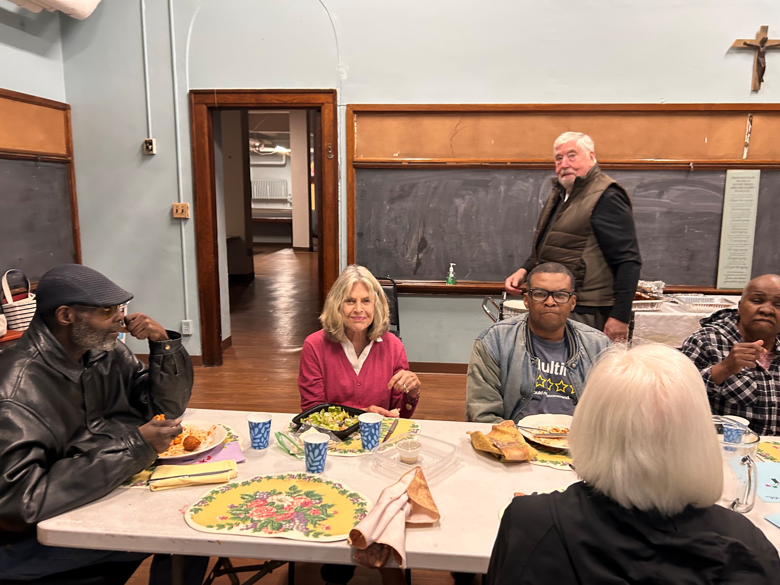
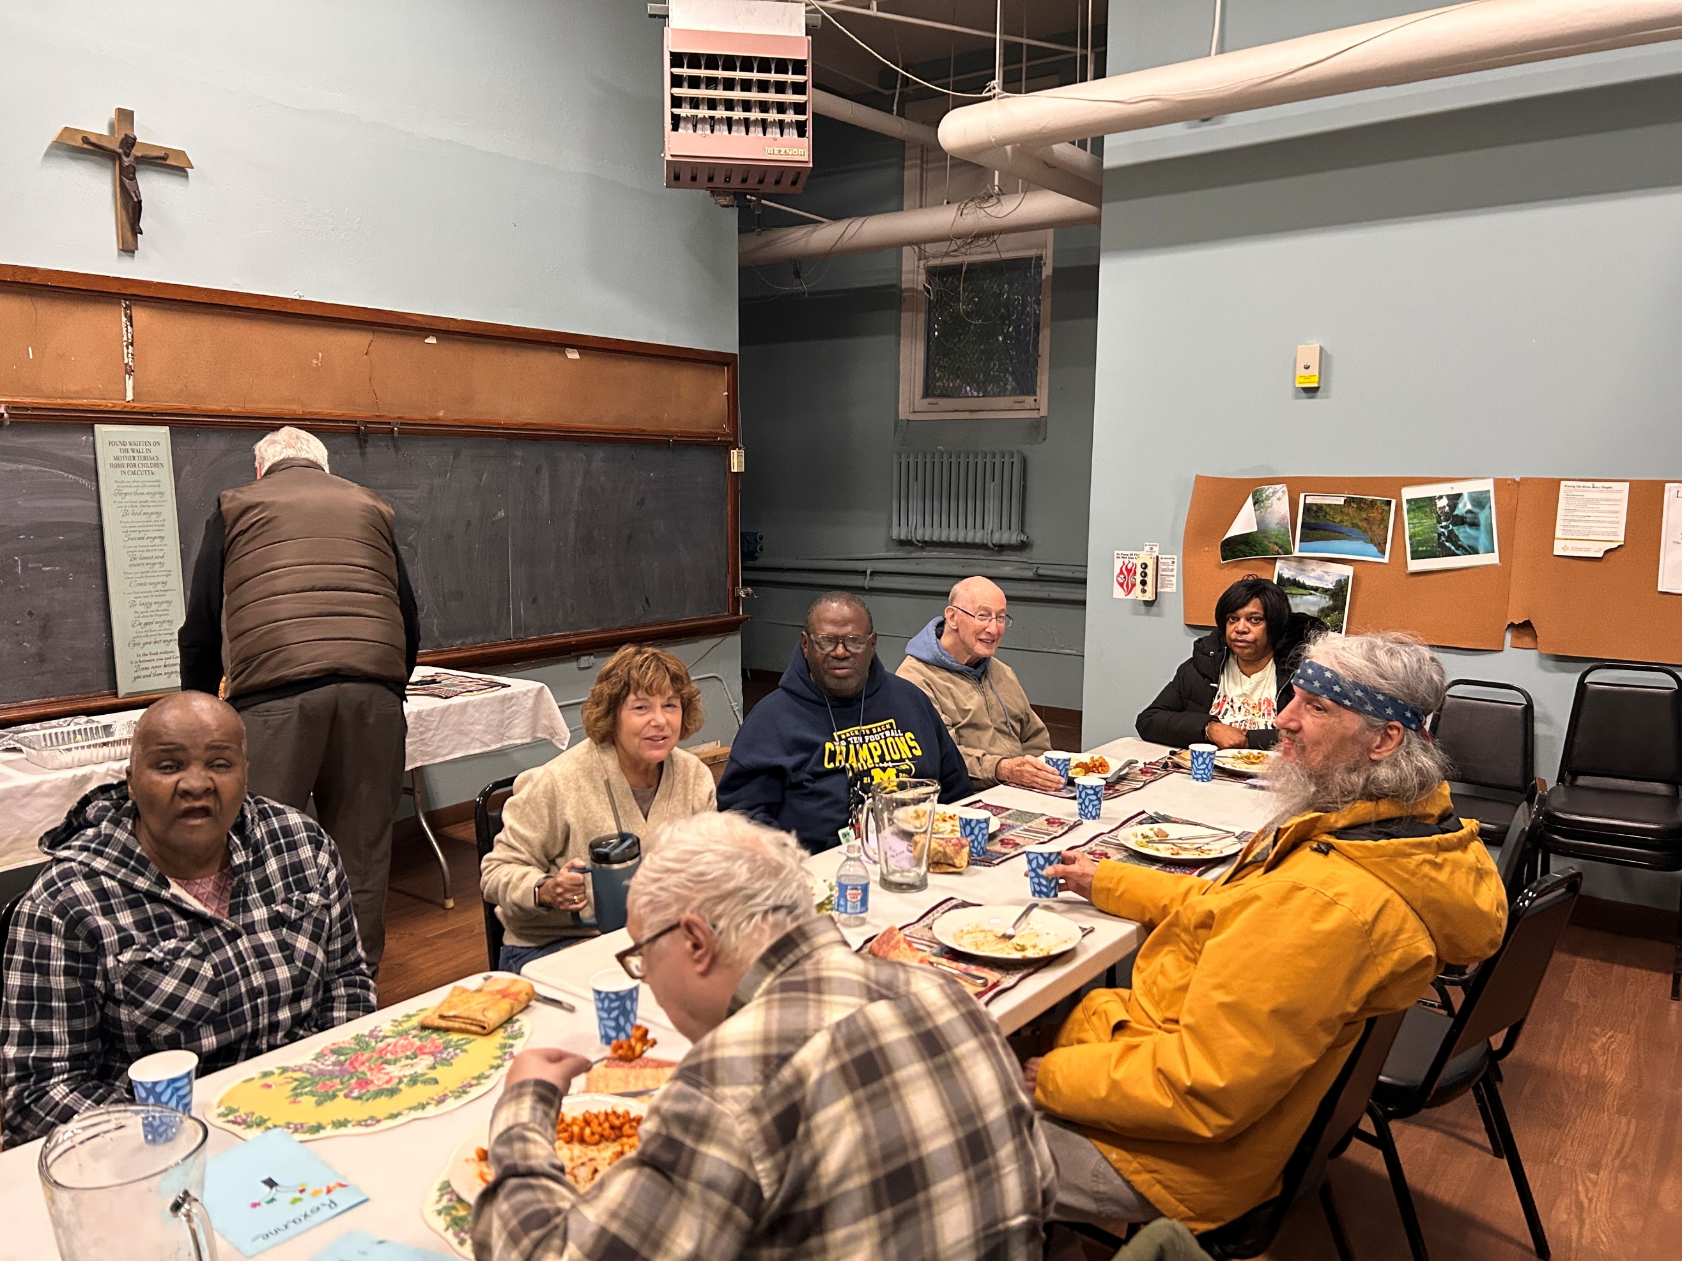
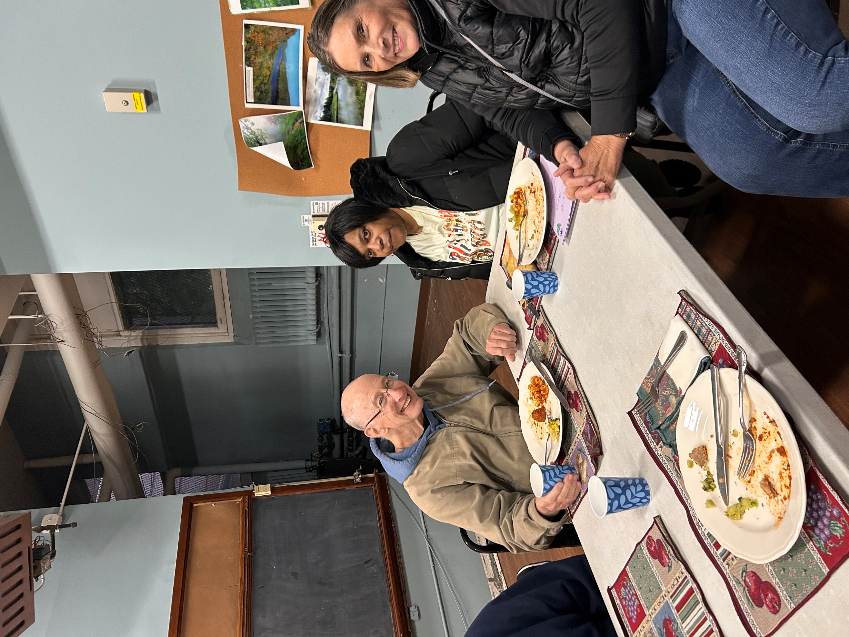

TODAY’S READINGS

Second Samuel 5: 1-3
(Shepherd My People)

Psalm 122: 1-2, 3-4ab, 4cd-5
(The House of the Lord)
Colossians 1: 12-20
(Primacy of Christ)

Mark 11: 9, 10
(Son of David)

Luke 23: 35-43
(The Crucifixion)
Jean-Marie Allion
Anderson and Miller Family
Paul Andrecovich
Kathy Ayoub
Mary Canaday
Jane Colombo
Kyle Duker
Jim Dutkiewicz
Doris Franklin
Anna Grabowski
Nancy Hayes
Carol Herman
Jim Howard
Joyce Hurley
Bertha Jackson-Hyde
Michelle Koss
Steve Lamendola
Michael Martin
Jacqueline Morant
Gloria Parham
Ronald Parham
Vertis Park, Sr.
Earlene Park-Williams
Orlando Richardson
Aaron Scott
Cherise Sweeney
Jonathan Taylor
Tommy Traylor
Anna Tyler
Guillerma Villanueva
Eldora White

Please call the rectory at 313-331-0253 to let us know when a name should be added to or removed from the list. Names will stay on the list for 3 months, but can be continued if we are notified of the wishes to do so.

PRAY FOR THE
HEALING PRESENCE

The VIGIL PRAYERS, READINGS, & FINANCE
The Holy Father’s Intentions
for the Month of
November 2025

For the prevention of suicide
Let us pray that those who are struggling with suicidal thoughts might find the support, care, and love they need in their community, and be open to the beauty of life.

COLLECTION INFO
11-16-2025

Collection $1,966.58
Online $1,047.00

TOTAL $3,013.58

READINGS FOR THE WEEK

Mon., Nov. 24: Daniel 1: 1-6, 8-20; Daniel 3: 52, 53, 54, 55, 56;
Matthew 24: 42a, 44; Luke 21: 1-4

Tues., Nov. 25: Daniel 2: 31-45; Daniel 3: 57, 58, 59, 60, 61; Revelation 2: 10c;
Luke 21: 5-11

Wed., Nov. 26: Daniel 5: 1-6, 13-14, 16-17, 23-28;
Daniel 3: 62, 63, 64, 65, 66, 67; Revelation 2: 10c; Luke 21: 12-19

Thurs., Nov. 27: Daniel 6: 12-28; Daniel 3: 68, 69, 70, 71, 72, 73, 74;
Luke 21: 28; Luke 21: 20-28

Fri., Nov. 28: Daniel 7: 2-14; Daniel 3: 75, 76, 77, 78, 79, 80, 81; Luke 21: 28;
Luke 21: 29-33
Sat., Nov. 29: Daniel 7: 15-27; Daniel 3: 82, 83, 84, 85, 86, 87; Luke 21: 36;
Luke 21: 34-36

Sun., Nov. 30: Isaiah 2: 1-5; Psalm 122: 1-2, 3-4ab, 4cd-5, 6-7, 8-9;
Romans 13: 11-14; Psalm 85: 8; Matthew 24: 37-44
STEWARDSHIP MINUTE

Stewards Grateful

“...giving thanks to the Father, who has made you fit to share in the inheritance of the holy ones in light.”
Colossians 1:12

God wants us to be happy! Instead of looking at the Ten Commandments as being restrictive and telling us what we can’t do, look at them as guides for living a joy-filled and peaceful life. Most of our problems arise when we put our own needs first or we spend most of our time trying to acquire more stuff. Instead, try putting God through Stewardship first in all things. We were made for God. Open your heart and let Him in!
.

MASS INTENTIONS

November 23, 2025
Patricia Sweeting
Gayle Koyton
Waletha McCrary

November 30, 2025
Keith Carson
Carolyn Carson
Angela McDonald

December 7, 2025
Kyria, Kenyanna and Frank Richardson

December 14, 2025
Kevin Scully
Fred Murphy
Patrick Cunniffe

December 21, 2025
George Zigas
Alexander Grabowski
Elfrieda Samuel

December 28, 2025
Steven and Catherine Bogotaitis
Kevin Scully

Black Catholic History Month
November 2025

Come to be known as our history too.
We are most human when we see the humanity in others.
- Author Unknown
Celebrating Black Catholic History Month Part II: Detroit’s Black Catholic History
Beginning in the late 1800s, chapels and missions were set up to accommodate the area’s growing Black populations. In 1911, the first Catholic Mission for African Americans was established in St. Mary’s Parish in Greektown. A year later it baptized its first child, Grayton Barksdale. In 1914, the mission was named for St. Peter Claver and moved into a new church home. The mission parish was both Black and culturally diverse with parishioners from Jamaica, Trinidad, Windsor, Ontario, Chile, Granada, Louisiana, Maryland, Kentucky, and Michigan. Staffed by Felician Sisters and Congregation of the Holy Ghost Fathers, an order dedicated to serving Black Catholics, these missions were established to give African American Catholics a place of respite from the racial harshness of the day, a place of belonging, prayer, religious education and hospitality. St. Peter Claver opened a school in 1936 and then moved into the previous German parish, Sacred Heart Church, in 1938 located in Eastern Market which remains today a personal African American parish for the Archdiocese of Detroit.
A second Black Parish was established on Detroit’s westside in 1927 – St. Benedict the Moor. A young man, Norman DuKette, who helped with St. Mary’s mission, was named its first priest. Fr. Norman DuKette was the first Black priest ordained for Detroit, incardinated in 1926 by Bishop Michael James Gallagher. A third Black mission, Holy Ghost, was opened in 1939 in northeast Detroit and given parish status in 1946; in 1943, a Black mission in the Detroit-Ferndale area, Our Lady of Victory, was established since Blacks were not permitted to attend nearby parishes, including Presentation Parish. A fifth and very successful Black mission, St. George Parish, was started in north-central Detroit. Nearly 1,000 African American Catholics were baptized there from 1949-1965. Sadly, St. George Church closed in 1965 to make way for freeway construction.
The Detroit Rebellion occurred in the summer of 1967 and was considered one of the most violent demonstrations in the U.S. of the 20th century. The Rebellion was due to tensions caused by a lack of educational opportunities, inadequate and segregated housing and unemployment. The Rebellion started at 12th street and made its way to the Boston-Edison neighborhood, adjacent to Sacred Heart Major Seminary (SHMS) in Detroit. An African American artist painted the face, hands and feet of the Sacred Heart of Jesus image that is in front of the seminary. A topic of controversy for many years, the Black painted Jesus has become a landmark and symbol of Jesus’ love for all races of people. Mary Massingale, a researcher for SHMS wrote for Detroit Catholic, “Bishop Boyea called the painting a ‘great blessing’ for the seminary: ‘It was a sign that we are not somehow immune to what takes place all around us, and it is a call to be engaged.’”
In 1970, the Archdiocese of Detroit established an Office of the Black Secretariat, one of the first offices in the nation to monitor relations between Blacks and Whites. In 1981, the Secretariat Office was closed and the Office of Black Catholic Affairs was established to address the spiritual, familial and social needs of the area’s Black Catholics. Today, there are 15-18 local Catholic parishes with a strong Black presence. The Affairs office is now the Office of Black Catholic Ministry which is in the Cultural Ministries Office within the Department of Evangelization and Missionary Discipleship in the Archdiocese of Detroit.

Parish Nurse Notes and Notes

November is Lung Cancer Awareness Month

November is Lung Cancer Awareness Month, a time to raise understanding, encourage prevention, and support those affected by this disease. Lung cancer remains one of the most common cancers worldwide, but early detection and healthy lifestyle choices can make a life-saving difference.

Know the Risk Factors:

Smoking is the leading cause, but even non-smokers can be affected.

Secondhand smoke, radon exposure, and air pollution also increase risk.

Steps for Prevention:

If you smoke, consider making this the month to quit—resources and support are available.

Test your home for radon and avoid exposure to harmful fumes.

Stay active and eat a balanced diet rich in fruits and vegetables.

Early Detection Matters:
If you are a current or former smoker aged 50–80, talk with your healthcare provider about low-dose CT screening, which can detect lung cancer early—often before symptoms appear.

Let’s take this month to breathe easier by caring for our lungs and supporting those in our community facing lung cancer.

A Moment for Reflection:
"The breath of the Almighty gives me life." — Job 33:4

This month, as we focus on lung health, let us remember that every breath we take is a precious gift from God. The simple act of breathing reminds us of His sustaining presence and grace in our lives. May we use each breath to bring encouragement to others, to offer prayers for those battling illness, and to give thanks for the life and healing power that God provides.

Let us pray for all who struggle to breathe easily, for caregivers, and for continued wisdom in prevention and treatment—trusting in the God who gives us life with every breath.

God Bless
Mary Catherine Wright RN Parish Nurse

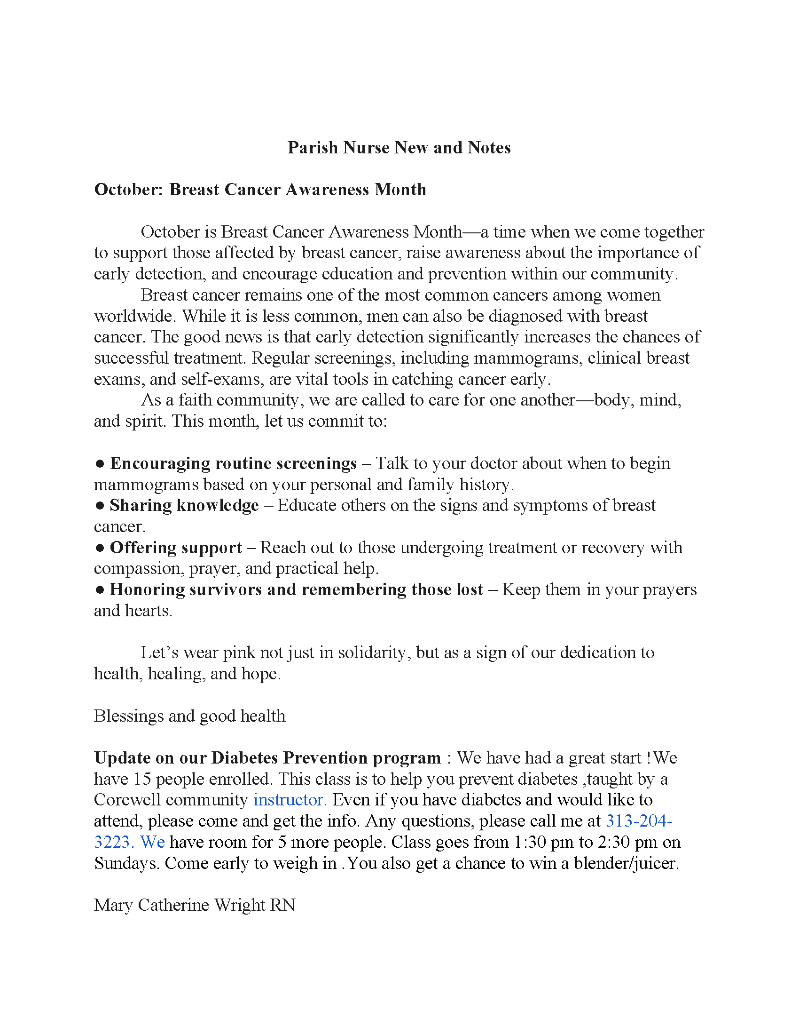

Detroit Lower Eastside and Trinity Family Parish Information

St Charles Borromeo Detroit  1491 Baldwin  Detroit, MI 48214  313-331-0253  www.stcharlesborromeodetroit.org  stcharlesborromeodetroit@yahoo.com | Sacred Heart  1000 Eliot St.  Detroit, MI 48207  313-831-1356  www.sacredheartdetroit.com  info@sacredheart.com
Nativity of Our Lord  5900 McClellan  Detroit, MI 48213  313-922-0033  www.nativitydetroit.org  nativityol@sbcglobal.net | St. Elizabeth  3138 E. Canfield St.  Detroit, MI 48207  313-921-9225  www.stelizabethdetroit.org  saintelizabethchurchofdetroit@gmail.com
St Augustine & St Monica  4151 Seminole  Detroit, MI 48214  313-921-4107  www.saintamparish.org  office@saintamparish.org | Trinity Family  20103 Joann  Detroit, MI 48205  313-527-0525  www.straymondolgc.org

TRINITY FAMILY OF PARISHES
MASS TIMES
Our Lady Queen of Heaven
Sunday: 9am
Tuesday: 10:30am
Thursday: 10:30am
Friday: 10:30am
Saturday: 4pm
St. Raymond
Sunday: 10:30am
Tuesday: 8:30am
Thursday: 8:30am
St. Jude
Sunday: 10:30am
Saturday: 4pm

DETROIT LOWER EAST SIDE FAMILY OF PARISHES MASS TIMES
St Charles Borromeo Detroit
Sunday: 11:30am
Friday: 11am in rectory
Live Stream & YouTube
Nativity of Our Lord
Sunday 9:30am
Thursday: Holy Hour 8am; Mass 9am
Live Stream and YouTube

St Augustine / St Monica
Mass Times
Sunday: 10am
Wednesday: 9am

Sacred Heart
Sunday: 8am and 10am
Tuesday: 5pm
Saturday: 5pm

St. Elizabeth
Sunday: 12:00pm

Event You May Be Interested In
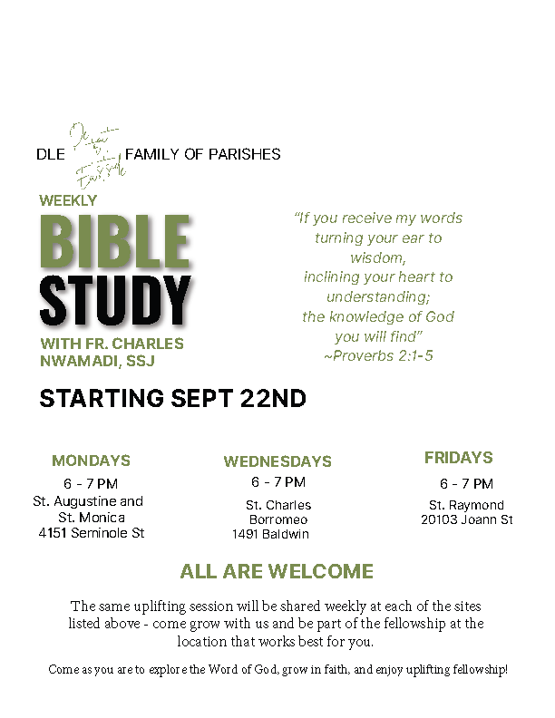
Please bring along your Catholic Bible
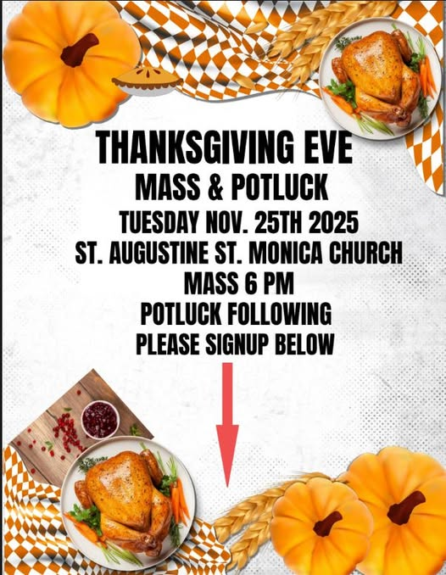

See the sign-up sheet on the back table in church to sign up and let us know what you will bring to share

Do you need to complete Protecting God’s Children Training?
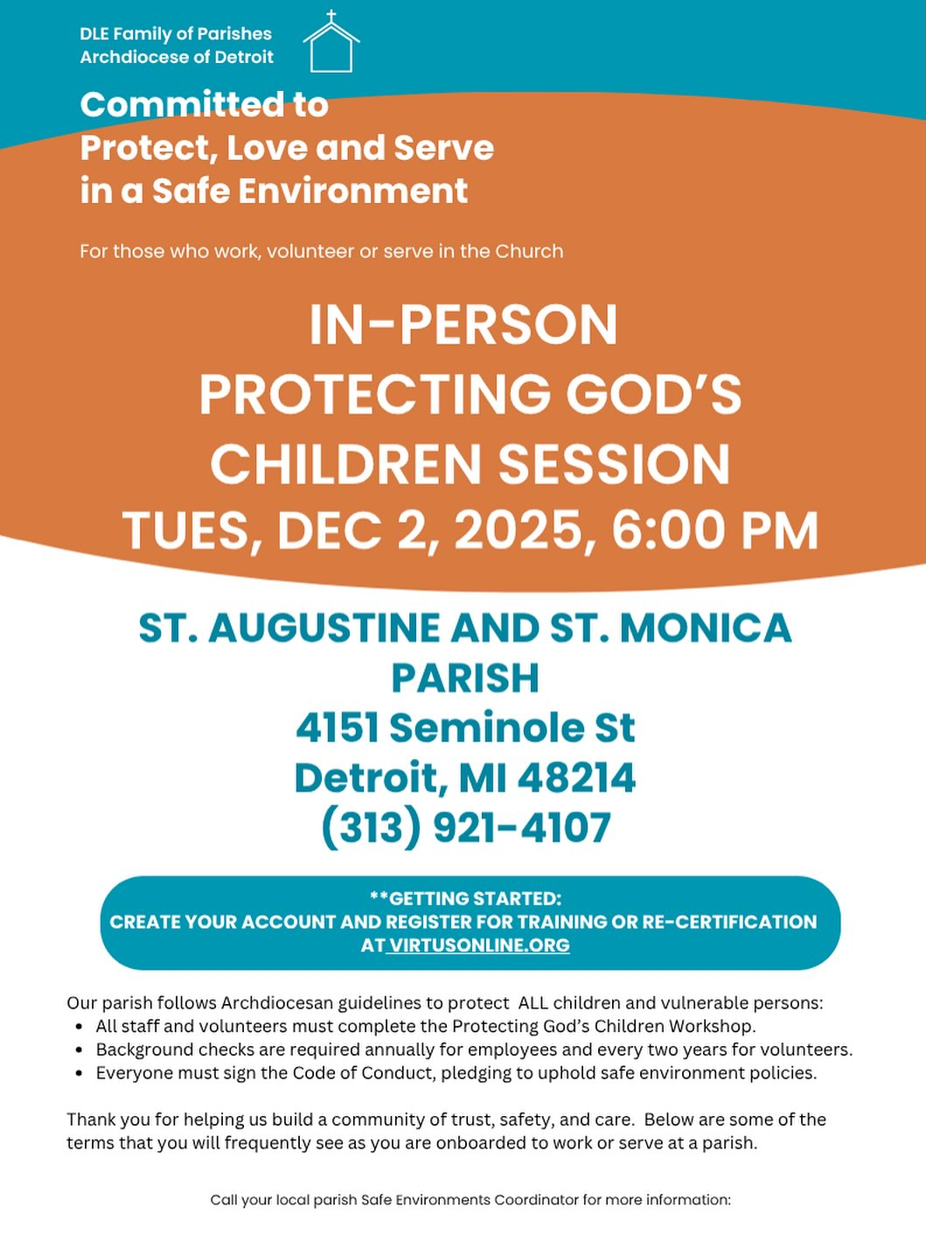

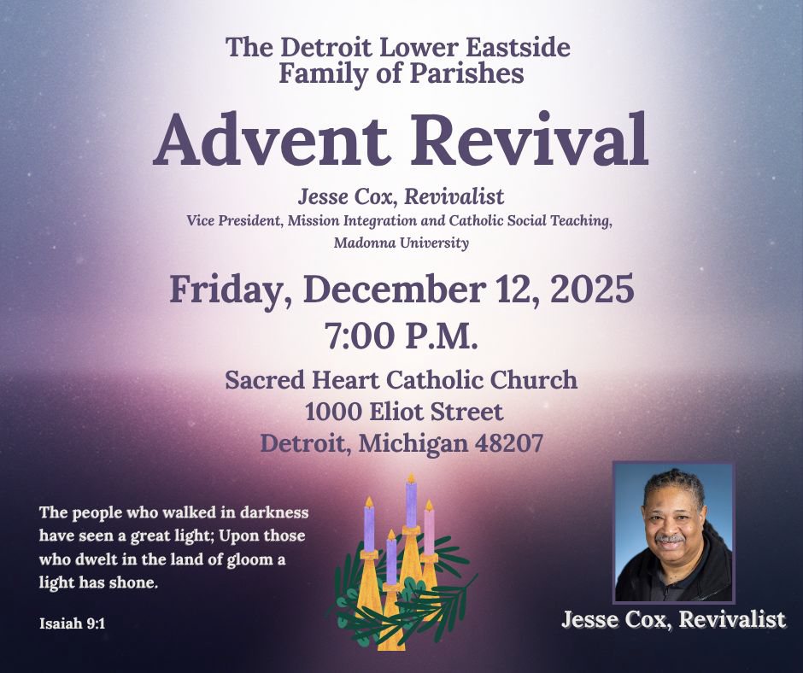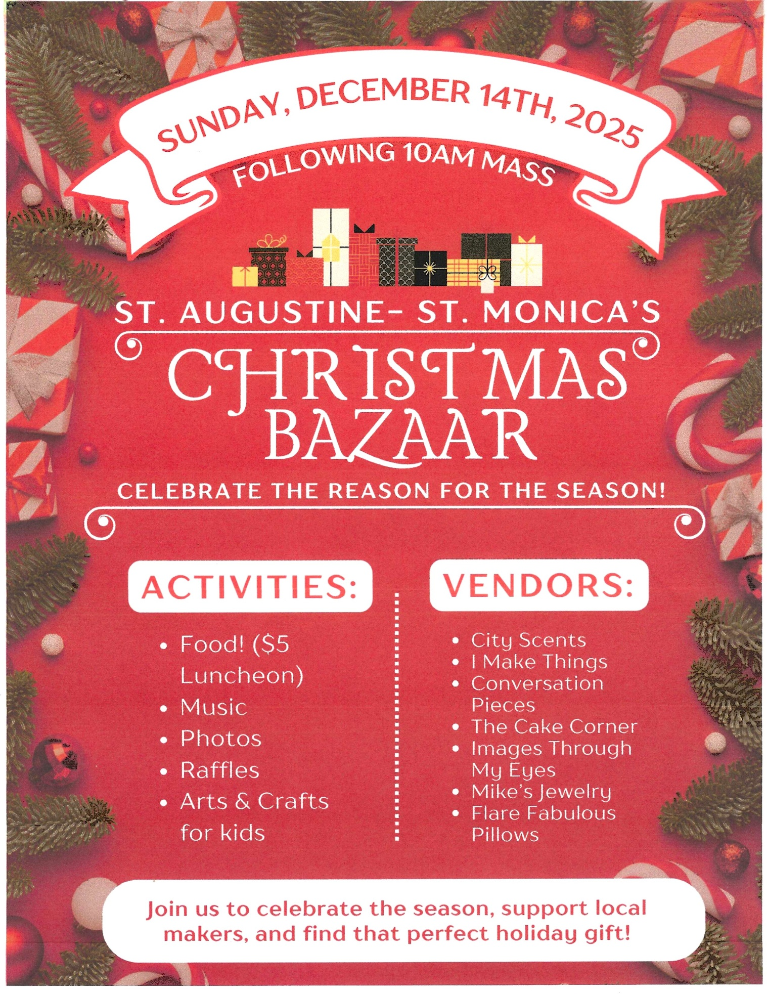

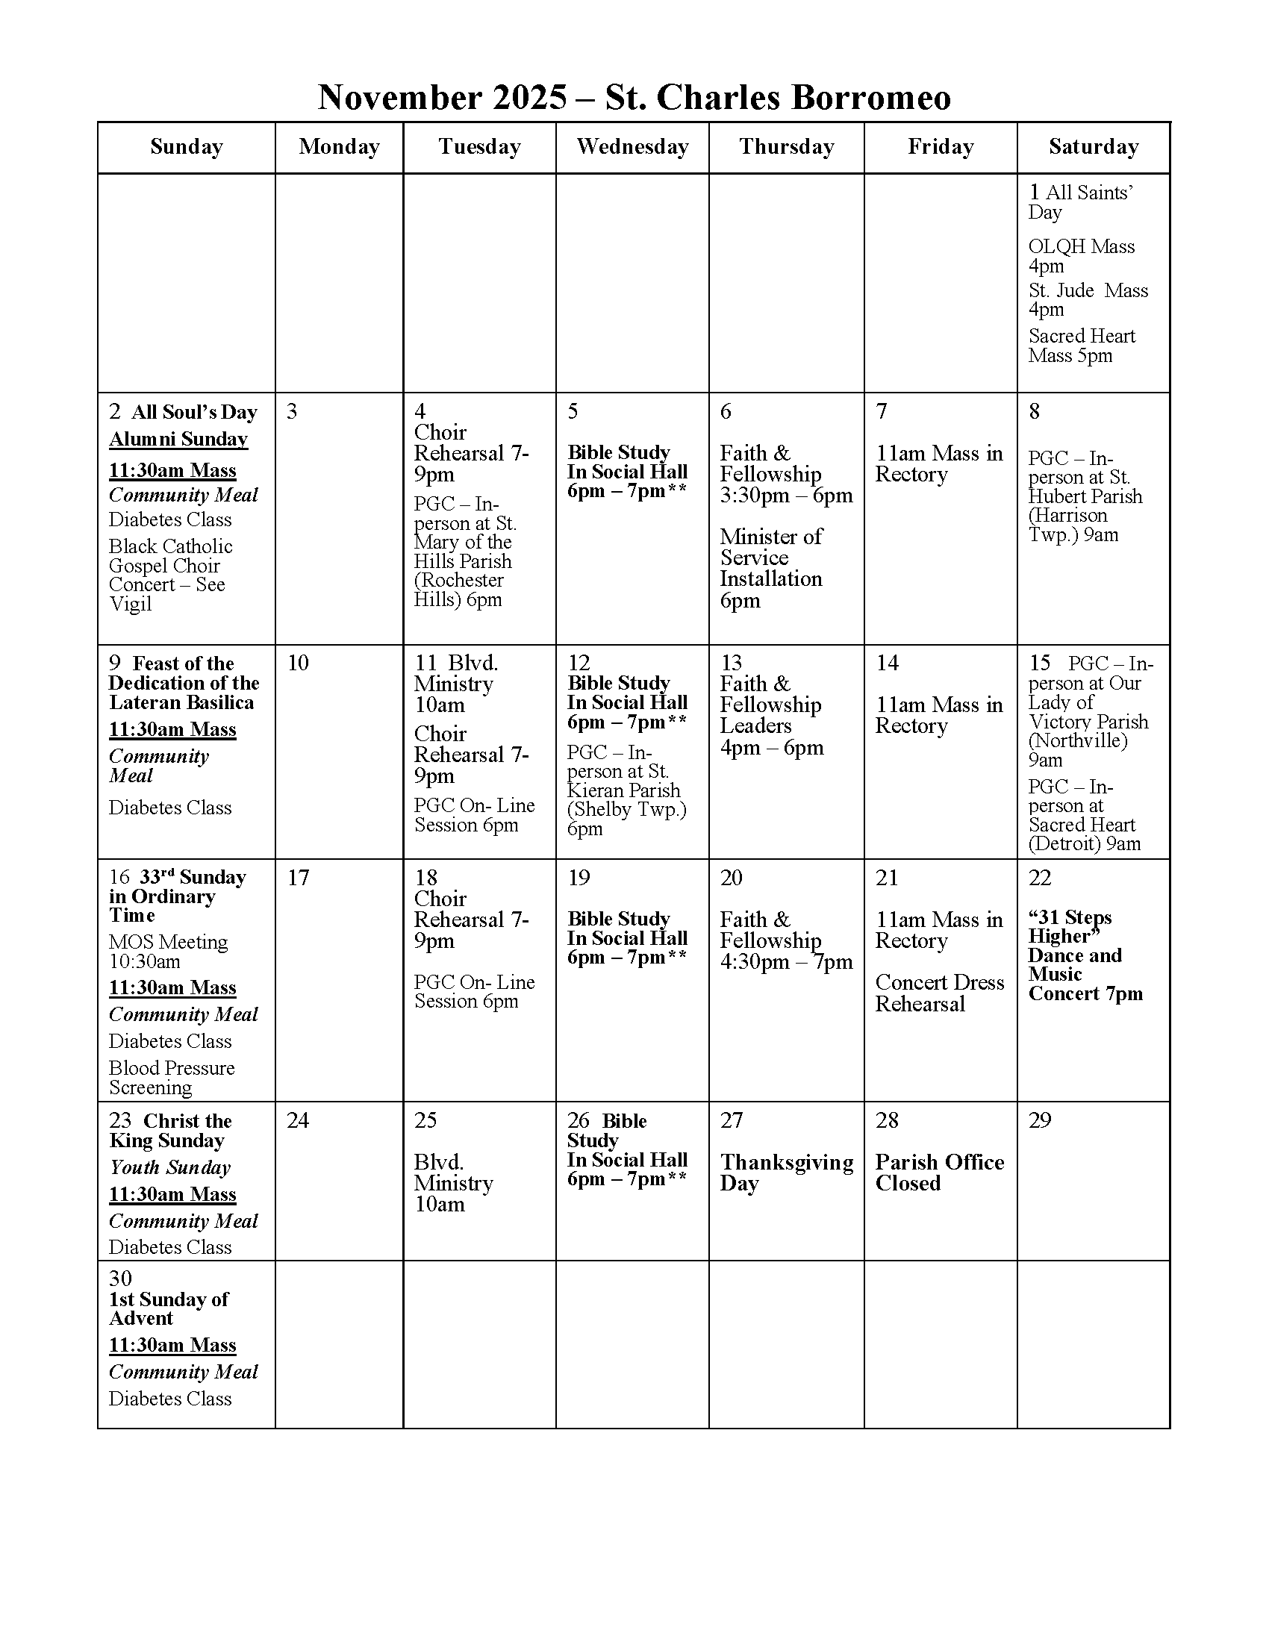
St Charles Borromeo
1491 Baldwin St., Detroit, MI 48214
(313) 331-0253 (Fax 313-331-4834)

St. Charles Office Hours:
Monday, 10am to 3pm
Tuesday, Wednesday, Thursday, 9am to 4pm
Friday, 9am to 3pm

Pastoral Team
Fr. Francis Asomkase, SSJ, Priest in Solidum and Moderator
Fr. Richard Baumann, Priest in Solidum
Reverend Charles Nwamadi, SSJ, Priest in Solidum
Fr. David Preuss, OFM, CAP, Priest in Solidum
Deacon Joseph Jones
Edward Cotton – Mission Support Director
Rhonda Gilbert – Pastoral Associate
Joan Jacobs & Angie Kadowaki – Boulevard Ministry Ministers
Mary Catherine Wright – Parish Nurse

Council Members: Naim Edwards (Chairperson), Angela Kadawaki, Dennis Ballard (Vice-Chairperson), Patricia Ballard, Alex Grabowski, Marian Harvey (Secretary), Freddie Henry, Mary Ellen Howard, Bruce McDonald, Mikhail Perkins, Richard Preuss, Linda Simpkins

The VIGIL PARISH & ARCHDIOCESAN INFORMATION
AOD Restructuring
St. Charles Parish Leaders

Doris Allen
Alex Grabowski
Joan Jacobs
Bruce McDonald
Richard Preuss

Parish Point Person of Contact

Rhonda Gilbert

St. Charles Mission Statement

St. Charles Borromeo, a diverse urban parish of Detroit, is rooted in Christ’s Gospel and Catholic tradition. We strive to build a community of faith through education, worship, and evangelization. We are called to carry on Christ’s ministry to our brothers and sisters, especially the sick and their families, the elderly, youth, and the disabled. With Mary as our example of unconditional love, we strive to welcome everyone to share joyfully in the peace, love and salvation of Jesus Christ. We acknowledge that it is the Holy Spirit who calls and empowers us, who strengthens and renews us, and who gives us the will to continue our mission, until Jesus comes.

St Charles Website: www.stcharlesdetroit.org
Email: stcharlesborromeodetroit@yahoo.com

Facebook: St. Charles Borromeo Parish - Detroit MI
YouTube: www.youtube.com/@st.charlesborromeodetroit

